**How to Create Workflow in SharePoint for a Library?**

Browse to a list or library where you want to create a SharePoint workflow.

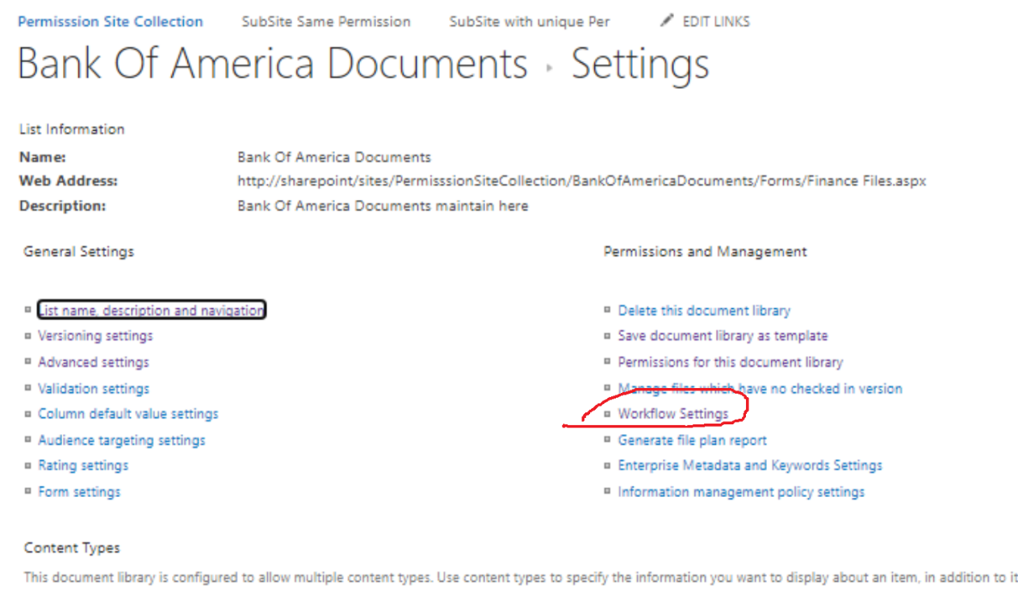

Select “Library Settings” tab and click “Workflow Settings” on the ribbon. Then select “Add a workflow” from the dropdown menu.

Click “Next” and define workflow behavior on the following page. You can specify the approvers list and carbon copy watchers, define the way how and when tasks are routed to participants, and set circumstances for workflow completion. Let’s name it “SharePoint workflow settings” page, because we have to deal with it after a few more steps.

Click Save. Now, you have to start this SharePoint workflow.

TO Start the workflow

Add a document in the document library

And start the workflow

Verify and Click to start the workflow

It will cerate a task for the assigned user and send notification the approver

Approver login and review the document and do the decision – Approve/Reject/Reassign

It will automatically update the Task and document status

